Q1)Brief about SplitMAC Architecture and how it improves the AP’s performance  
  
**SplitMAC Architecture in Wi-Fi**

### SplitMAC is a centralized wireless network architecture where the **Media Access Control (MAC)** layer functions are divided between **Access Points (APs)** and a central controller (e.g., a Wireless LAN Controller - WLC). This approach is commonly used in enterprise Wi-Fi deployments.

### If in a Wi-Fi network where **Access Points (APs)** are like "dumb radios" that just send and receive signals, while a **central brain (Wireless LAN Controller - WLC)** makes all the important decisions. This is the **SplitMAC architecture**.

### **("Dumb radios"** in SplitMAC architecture, mean that the **Lightweight Access Points (APs)** have **minimal intelligence**—they don’t make complex decisions on their own. Instead, they just follow orders from the central **Wireless LAN Controller (WLC)**.)

**Why Call Them "Dumb"?**

* They **do not** process security (like authentication or encryption).
* They **do not** decide when a device should roam to another AP.
* They **do not** optimize Wi-Fi channels or power settings.

They just:

* Transmit and receive Wi-Fi signals (like a walkie-talkie).
* Forward data to the WLC for processing.
* Execute basic commands (like broadcasting beacons).

**Analogy: A Speaker vs. a Smartphone**

* **"Dumb" AP** = **Speaker** (just plays sound, doesn’t decide what to play).
* **WLC** = **Smartphone** (chooses the music, volume, and playlist).

**Why Use "Dumb" APs?**

1. **Cheaper** – No need for powerful processors in each AP.
2. **Easier to manage** – All settings come from the WLC (no manual config).
3. **More consistent** – Every AP behaves the same way (no conflicts).

**What Makes Them "Smart"?**

The **intelligence** is in the **WLC**, which:

* Handles **security** (like 802.1X, firewalls).
* Manages **roaming** (seamless handoffs between APs).
* Optimizes **Wi-Fi performance** (auto-adjusts channels & power).
* **"Dumb" APs** = Basic radios that follow orders.
* **"Smart" WLC** = The brain that controls everything.

**Use Cases:**

This setup is perfect for **large Wi-Fi networks** (like offices, campuses) where **centralized control** is better than managing each AP individually.

With Split MAC , the 802.11 protocol functionality is divided between AP & WLC.

General rule is:

* All real-time tasks are handled by AP (such as Probe Response, Packet buffering, Fragmentation, Queuing)
* Non real-time tasks handled by WLC (Such as Association / Di-association, Classifying, 802.1x/EAP authentication, etc)

### ****Protocols Used:****

* **CAPWAP** (Control And Provisioning of Wireless Access Points) – Standard protocol for communication between APs and WLC.

SplitMAC improves scalability and manageability compared to traditional **Autonomous APs** (where each AP works independently).

**CAPWAP** (Control And Provisioning of Wireless Access Points) is the key protocol that allows **Lightweight Access Points (APs)** and a **Wireless LAN Controller (WLC)** to communicate in a **SplitMAC Wi-Fi architecture**.

It is the **language** that dumb APs and the smart controller use to coordinate everything in a large Wi-Fi network.

## ****How CAPWAP Works?****

CAPWAP has **two main functions**:

1. **Control Messages** – For management (e.g., "Change your Wi-Fi channel").
2. **Data Forwarding** – For sending/receiving user traffic (e.g., video calls, downloads).

### ****1. CAPWAP Control Channel (Secure Management)****

* Used for sending **commands** from the WLC to APs.
* Examples:
  + "Switch to Channel 6, AP-05!"
  + "A new device just connected—authenticate it!"
  + "Reduce your power to avoid interference!"
* Runs over **UDP port 5246** (default).

### ****2. CAPWAP Data Channel (User Traffic)****

* Used to **tunnel** Wi-Fi user data (like web browsing, YouTube) back to the WLC.
* Runs over **UDP port 5247** (default).
* The WLC can inspect, prioritize, or filter traffic before sending it to the internet.

## ****Why CAPWAP is Important?****

✔ **Centralized Control** – All APs get commands from one WLC.  
✔ **Seamless Roaming** – Devices switch APs without dropping calls.  
✔ **Security** – Encrypted communication between AP and WLC.  
✔ **Flexibility** – APs can be far from the WLC (even over the internet).

## ****CAPWAP Modes: Local vs. Split MAC****

|  |  |  |
| --- | --- | --- |
| **Mode** | **Where Traffic Goes** | **Use Case** |
| **Local MAC** | Data stays at AP (only control goes to WLC) | Good for small offices |
| **Split MAC** | All traffic tunnels to WLC (full control) | Enterprise networks (most common) |

Diagram shows how Split MAC architecture works where AP & WLC have their dedicated responsibilities:

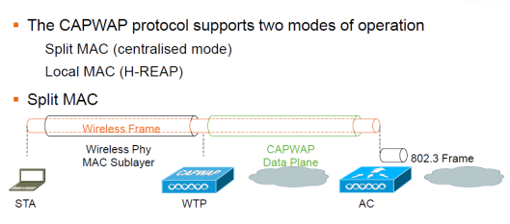

In Local MAC mode AP is doing all of the functions including the one done by WLC in Split MAC architecture:

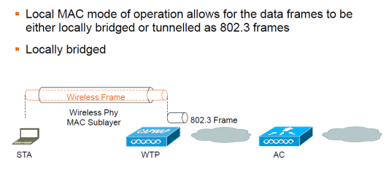

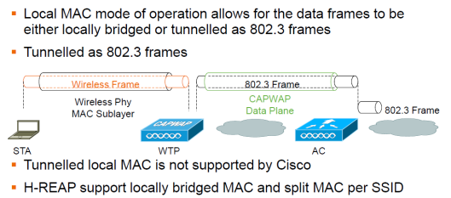

Below diagram shows the CAPWAP State machine where you need to understand this in order to determine from where you should start troubleshoot if something is not working:

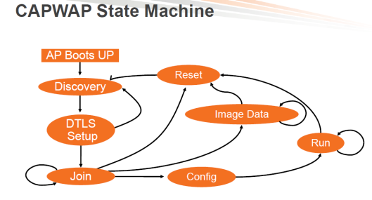

### ****How SplitMAC Improves AP Performance****

SplitMAC architecture enhances Wi-Fi performance by **offloading complex tasks** from individual APs to a centralized **Wireless LAN Controller (WLC)**, allowing APs to focus solely on **radio efficiency**. Here’s how it optimizes performance:

## ****1. Reduced AP Processing Overhead****

* **Before (Autonomous APs):** Each AP handles **security, roaming, RF management, and data forwarding** → High CPU/memory usage.
* **After (SplitMAC):** APs act as "dumb radios" → Only handle **real-time transmission/reception**, while the WLC manages:
  + Encryption/decryption (WPA3, 802.1X)
  + Client authentication
  + QoS (prioritizing voice/video traffic)

**Result:** APs run cooler, support more devices, and avoid bottlenecks.

## ****2. Smarter Radio Resource Management (RRM)****

The WLC continuously monitors and optimizes:

* **Channel Selection** – Avoids interference by auto-assigning non-overlapping channels.
* **Transmit Power Adjustment** – Balances coverage (e.g., reduces power if APs are too close).
* **Load Balancing** – Distributes clients evenly across APs to prevent congestion.
* **Result:** Fewer dead zones, less interference, and higher throughput.

## ****3. Faster Roaming (Seamless Handoffs)****

* **Problem:** In traditional Wi-Fi, devices hesitate when switching APs (brief disconnection).
* **Solution:** The WLC **pre-coordinates handoffs** using:
* **802.11k (Neighbor Reports)** – Helps devices find the best AP.
* **802.11r (Fast Transition)** – Speeds up re-authentication.
* **802.11v (BSS Transition)** – Encourages sticky clients to move.
* **Result:** No dropped calls (VoIP, Zoom) when moving between APs.

## ****4. Centralized Traffic Optimization****

* **QoS Handling:** The WLC enforces policies (e.g., video gets priority over downloads).
* **Band Steering:** Pushes dual-band devices to **5 GHz** (less crowded than 2.4 GHz).
* **Airtime Fairness:** Prevents slow devices from hogging airtime.
* **Result:** Better latency, fewer buffering issues, and smoother streaming.

## ****5. Improved Security & Scalability****

* **Security Offload:** The WLC handles firewall, intrusion detection (IDS), and encryption.
* **Zero-Touch Provisioning:** New APs auto-configure via CAPWAP → Faster deployment.
* **Scalability:** A single WLC can manage **100s of APs** without performance loss.
* **Result:** More reliable, secure, and easier-to-expand networks.

### ****Real-World Impact****

* **Voice/Video Calls:** No jitter or drops when moving.
* **High-Density Areas** (stadiums, offices): More stable connections.
* **IT Management:** Fix issues globally (e.g., update all APs at once).